Sometimes a Light Surprises the Christian While He Sings
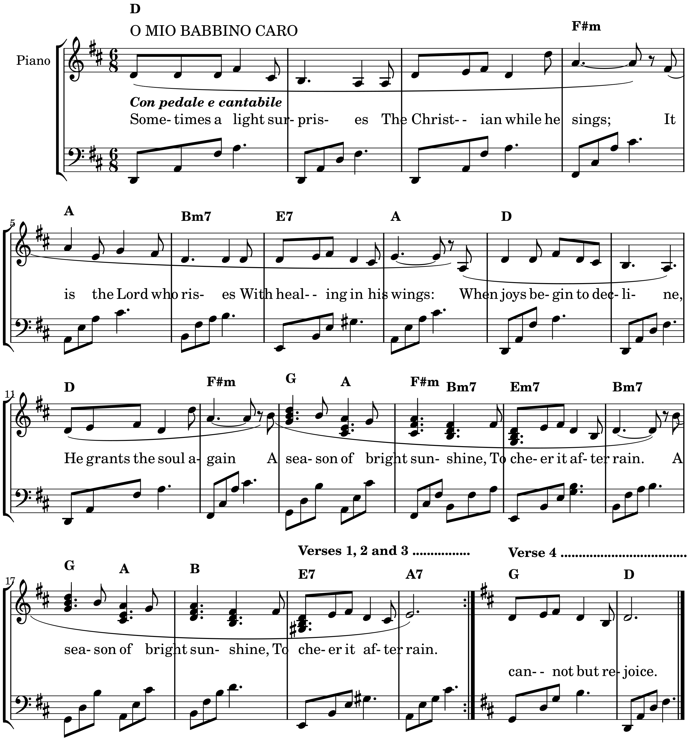
2. In holy contemplation,  We joyfully then pursue  The theme of God's salvation,  And find it ever new:  Set free from present sorrow,  We cheerfully can say:  We'll let unknown tomorrow  Bring with it what it may. (rpt.) | 3. It can bring with it nothing  But he will bear us through;  God gives the lilies clothing,  And clothes his people too:  Beneath the spreading heavens,  All creatures there are fed;  And he who feeds the ravens,  Will give his children bread. (rpt.) | 4. Though neither vine nor fig-tree  Their longed-for fruit shall bear,  Though all the crops should wither,  No flocks no herds be there:  Yet God for ever unchanging,  His praise shall tune my voice;  For while in him confiding,  I cannot but rejoice. (rpt.)
Words by William Cowper; altd. by David Legg (slightly modernised, Copyright in this form, 2008)

